**Star Wars Saga Reviews**

Orian Teodor Octavian

Group 30423_2



JavaFX Project

**App description:**

"Star Wars Saga Reviews" is the ultimate app for exploring and reviewing the entire Star Wars saga. Log in, rate, and review Episodes 1 to 9. Engage with the community and receive personalized recommendations based on your ratings. Immerse yourself in the world of Star Wars and share your opinions about each epic installment

**Here's a brief description of how the game usually works:**

**1.Login:** The user types in his username and password correctly in the text fields provided and after that he presses the login button.

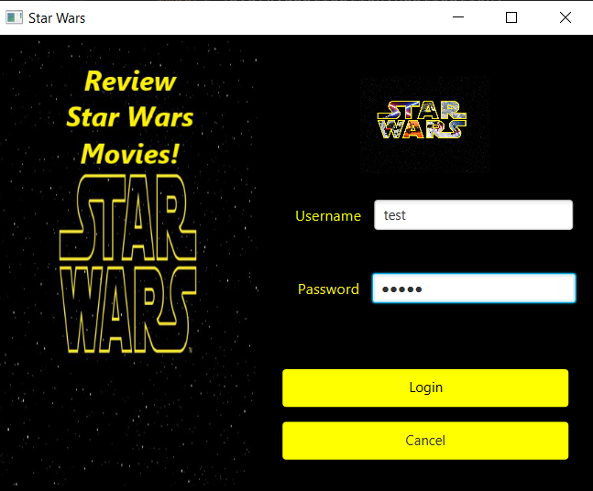

If the user puts in the wrong password, he will be asked to use the correct one.

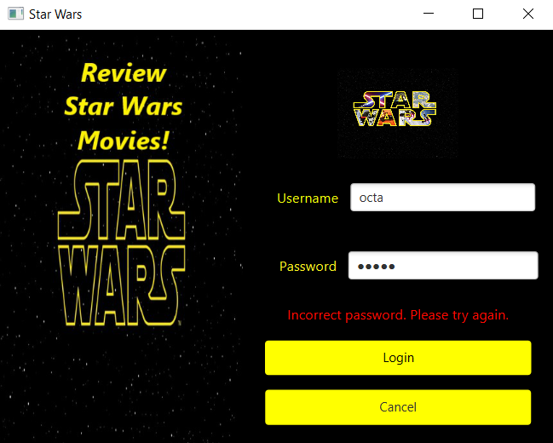

**2.Register:** If the username provided doesn’t exist in our database, the user will be directly redirected to the register page, where he needs to provide with the username he wants to use and the password, after that he can easily log in with the username and password he chose.

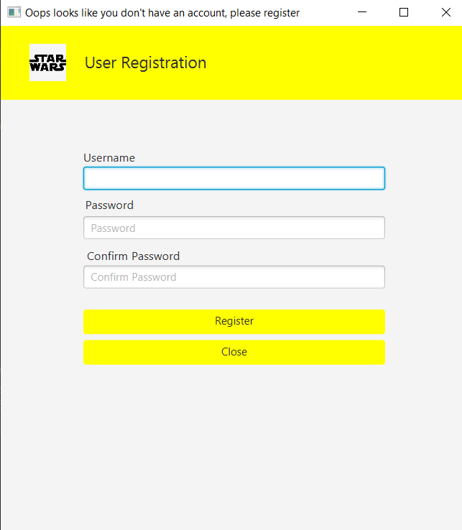

**3.Review:**  After the user successfully logged in, the following page has 2 functionalities. The first function presents the list of movies from 1-9 and the user can press the title of any movie to see its reviews. The second function is on the right side, where the user can select a movie from the list by writing its number, the rating he wants to give and a comment he wants to leave so that people know why the user gave that rating.

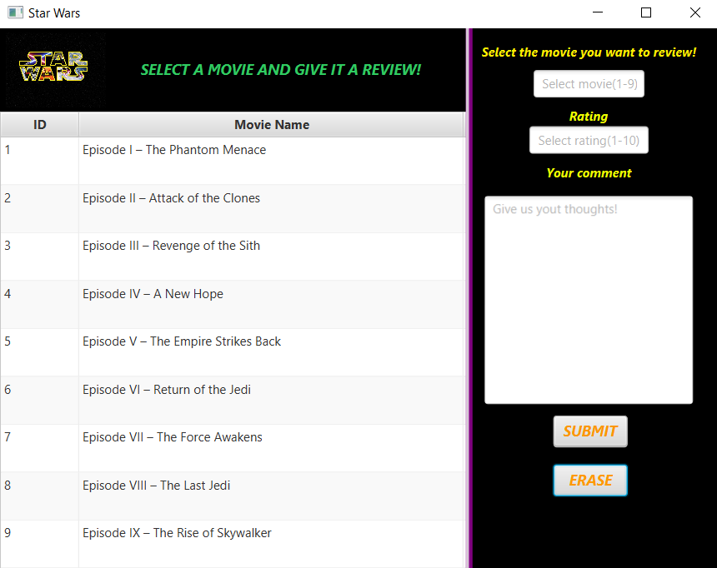

After the user selected the first movie title:

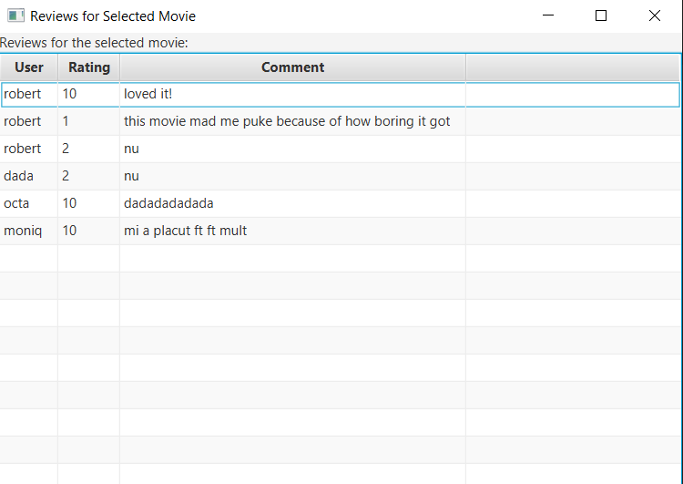

**We have a total of 8 classes:**

**1.Main**

The provided code is a JavaFX application that launches a window showing a login screen from an FXML file named "login.fxml". The window has the title "Star Wars" and a size of 520x400 pixels. The **start** method initializes the window, while the main method is the entry point of the program, calling the launch**()** method to start the JavaFX application.

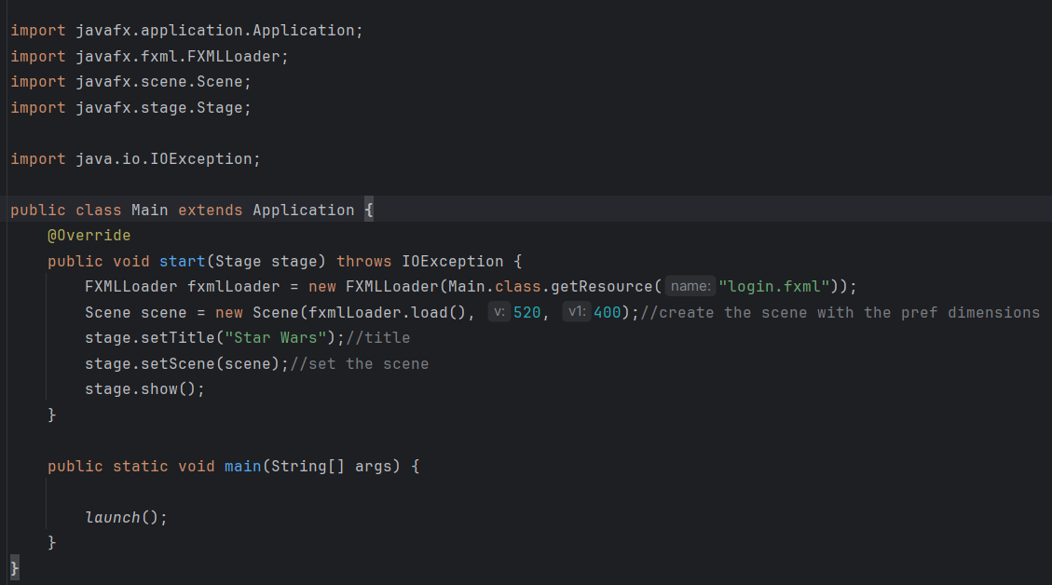

**2.DbFunctions**

The code defines a Java class named DbFunctions that establishes a connection to a PostgreSQL database using provided credentials. It includes a method getConnection**()** that returns the database connection or null if unsuccessful.

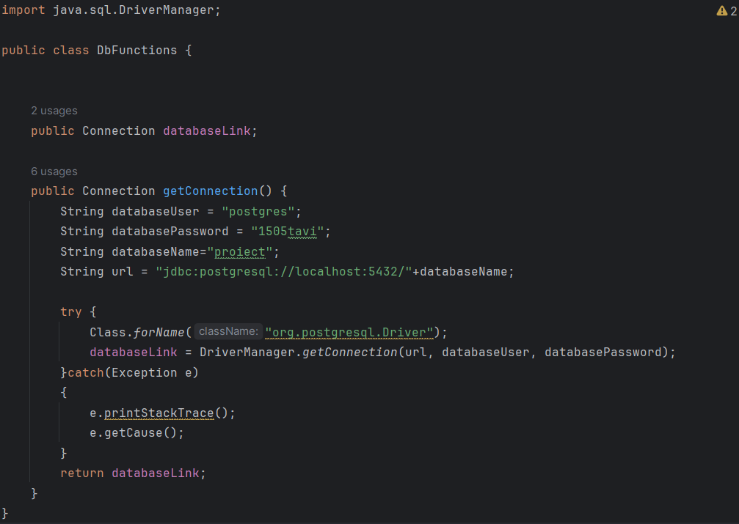

**3.User**

The code defines a Java class named User, representing a user entity with properties for user ID (userId) and username (username). It includes a constructor to initialize these properties and getter methods to retrieve them.

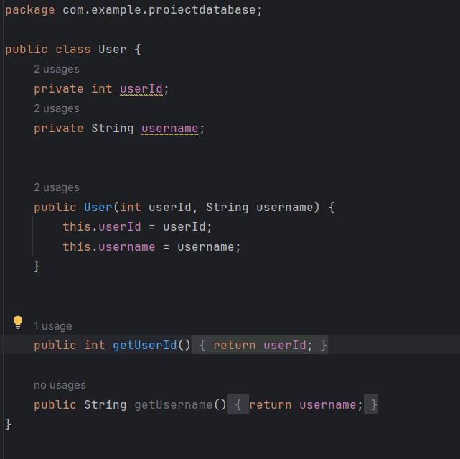

**4.Movie**

The code defines a Java class called Movie representing a movie entity. It includes properties for the movie's ID (id) and name (name) using JavaFX property types (IntegerProperty and StringProperty). Additionally, it provides getters and setters for these properties, enabling access to and manipulation of movie details.

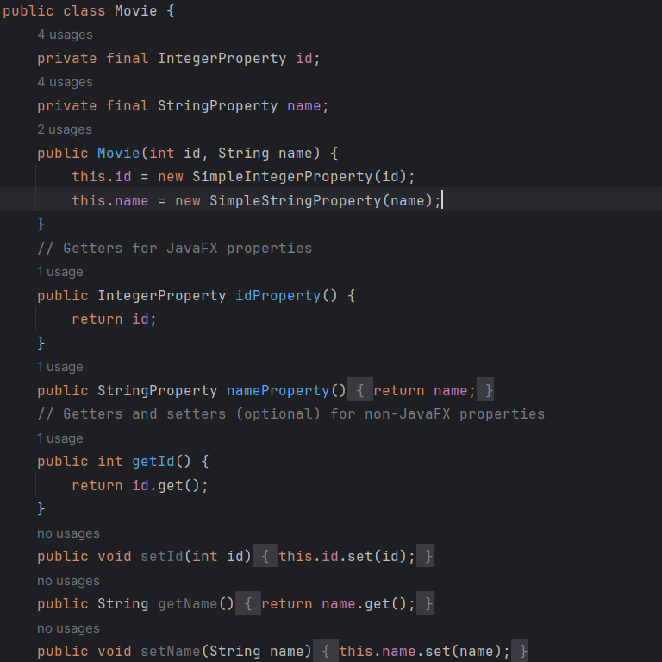

**5.LoginController**

The LoginController Java class manages the login functionality for a JavaFX application. It controls actions for buttons (cancelButton, loginButton) and displays login messages (loginMessageLabel). It validates user input, connects to a database, checks user credentials, and navigates to different scenes based on login success or failure.

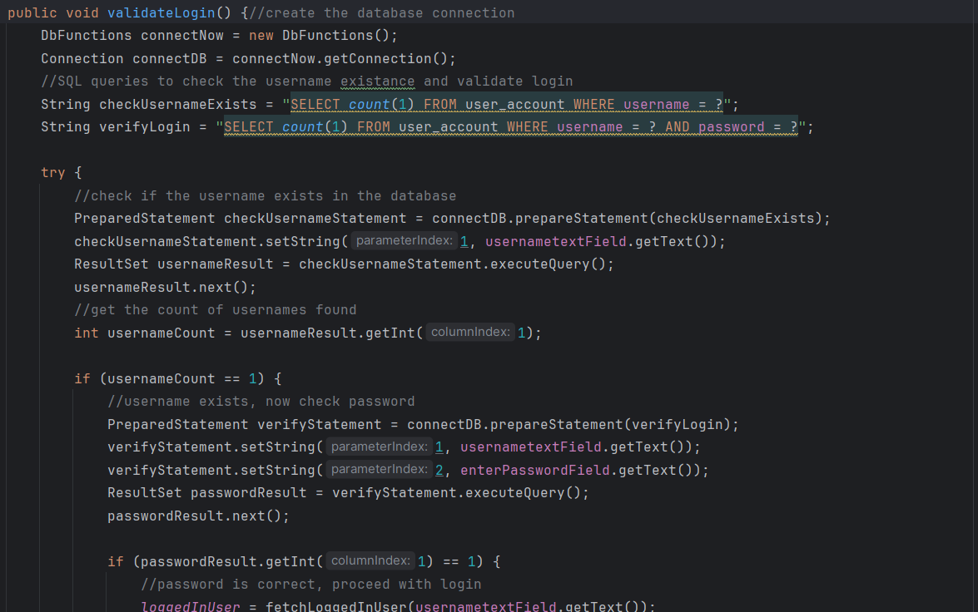

**6.RegisterController**

The RegisterController Java class handles user registration in a JavaFX application. It checks if passwords match, verifies username uniqueness in the database, and inserts new user details if the username is unique. The controller initializes the UI and responds to button clicks, providing registration feedback through labels.

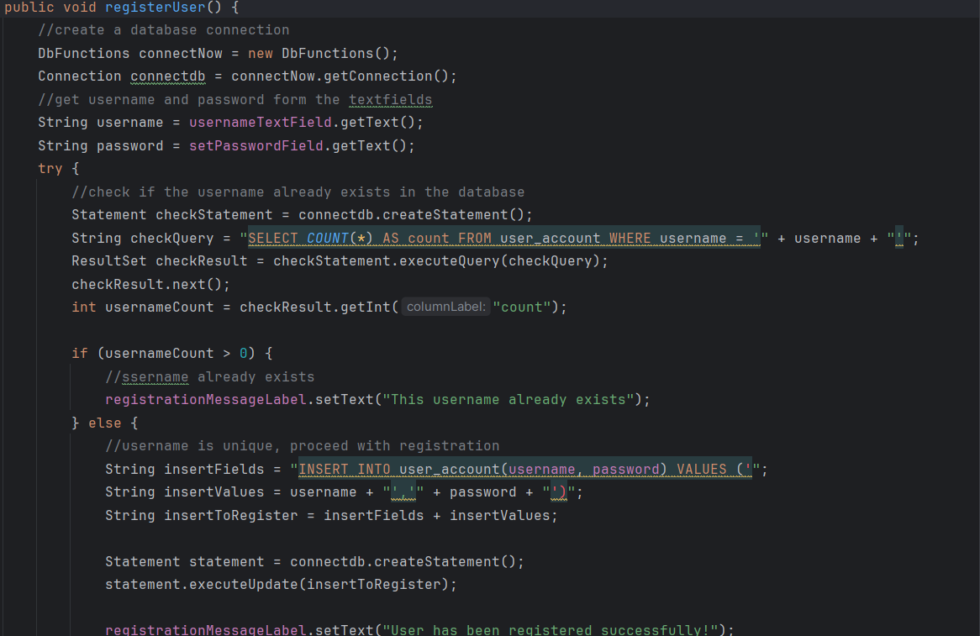

**7.MovieTable**

The MovieTable Java class handles displaying movies in a table and submitting reviews for selected movies in a JavaFX application. It populates the table with movie data fetched from a database and enables users to submit reviews with ratings and comments for movies.

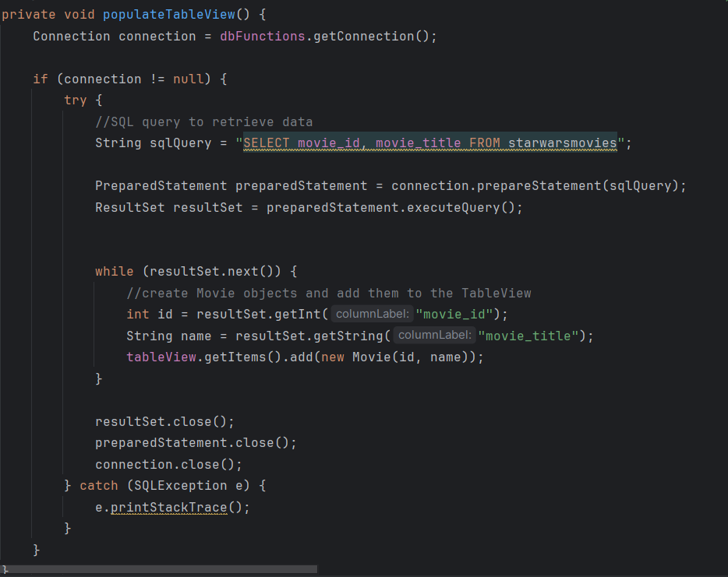

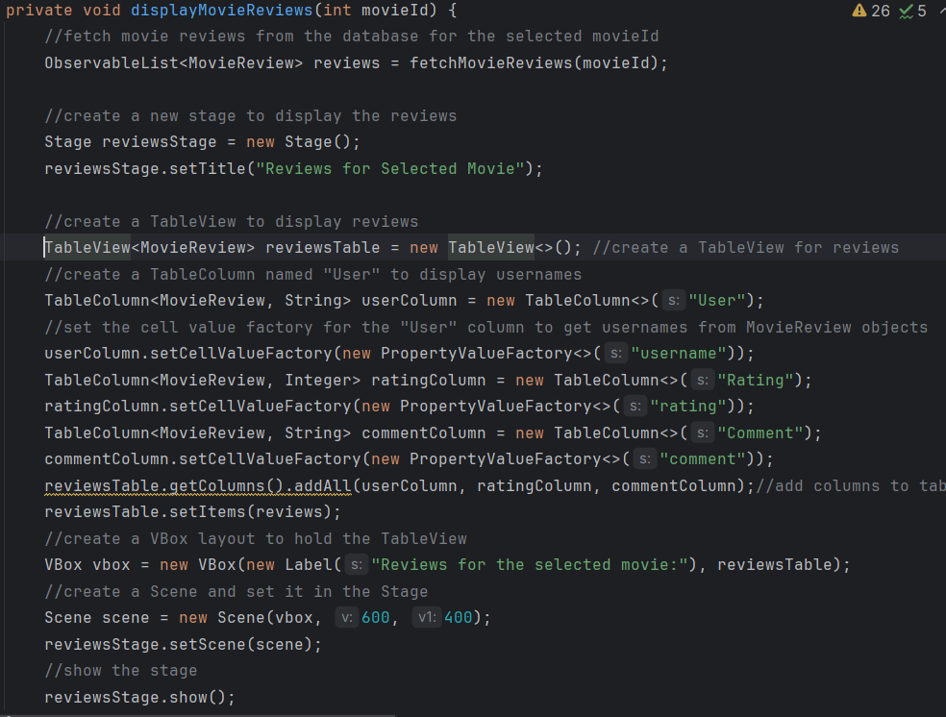

**Class Diagram**

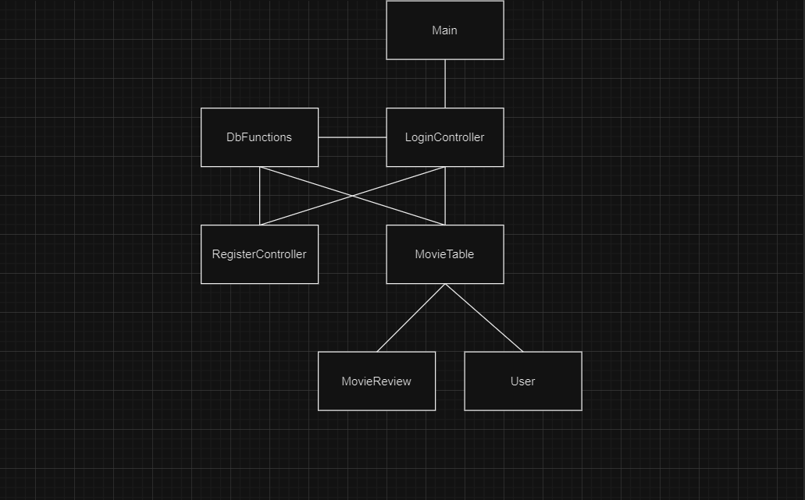

**Bibliography**

[**https://www.youtube.com/watch?v=ltX5AtW9v30&t=2780s&ab_channel=WittCode**](https://www.youtube.com/watch?v=ltX5AtW9v30&t=2780s&ab_channel=WittCode)

[**https://www.youtube.com/watch?v=tw_NXq08NUE&t=1799s&ab_channel=CodeAmir**](https://www.youtube.com/watch?v=tw_NXq08NUE&t=1799s&ab_channel=CodeAmir)

[**https://www.youtube.com/watch?v=pf7-zMCQlIc&list=PL9CzlNPNQEQ4YCJkl5_4eTH-f-rvF1xps&ab_channel=tookootek**](https://www.youtube.com/watch?v=pf7-zMCQlIc&list=PL9CzlNPNQEQ4YCJkl5_4eTH-f-rvF1xps&ab_channel=tookootek)

[**https://htmlcolorcodes.com/**](https://htmlcolorcodes.com/)

**https://www.youtube.com/watch?v=SKyDoyAZyOo&ab_channel=xemacscode**

[**https://stackoverflow.com/questions/38398050/javafx-tableview-not-showing-data-from-database**](https://stackoverflow.com/questions/38398050/javafx-tableview-not-showing-data-from-database)

**https://chat.openai.com/**